**2022F-T3 AISC2010 - Programming and Deployment of IoT Devices**

**2023F FINAL Group I**

**Contribution:**

|  |  |
| --- | --- |
| **Group Member Name** | **Contribution** |
| Asitkumar Patel (500211508) | Work on Trello and GitHub and documentation |
| Meeraben Gangani(500210808) | Did research and work Arduino code |
| Akil Khoja (500209564) | Work on Arduino code with Meera |
| Shivagnesh Birru (500211953) | Work on documentation |

**Disrupting the Electric Safe Box Industry with Advanced Security Features**

**Introduction of State of the Art (SOTA):**

The current state of the electric safe box industry in finance and banking relies on conventional lock-and-key mechanisms and basic electronic keypads. However, these solutions lack advanced security features, making them vulnerable to unauthorized access. The primary problem with the SOTA lies in its inability to adapt to modern security standards and the increasing sophistication of intrusion techniques.

**Device Description:**

The electric safe box we are creating for the finance and banking industry implements a servo-driven locking mechanism controlled by a secure keypad. The system incorporates an LCD for user interaction and feedback, addressing the specific challenges faced by financial institutions. This device offers enhanced security through a programmable secret code and a motorized locking system.

**Technical Challenges:**

* Secure Code Handling: Ensuring the safe storage and retrieval of the secret code is crucial in the finance sector. The code is securely stored in EEPROM for non-volatile memory.
* Servo Motor Precision: Precise control of the servo-driven locking mechanism is essential to prevent mechanical failures.
* User Interface: A secure and intuitive user interface is paramount in the finance industry, with challenges including code entry validation and seamless user experience.
* Future-Proof Design: Anticipating advancements in financial security standards is vital for the device's longevity, requiring a flexible and upgradable firmware architecture.

**Regulatory Challenges:**

Data Security Compliance: Strict adherence to data protection regulations in the finance sector is imperative. The device implements encryption and secure storage practices.

Servo Motor Safety Standards: The locking mechanism's servo motor complies with rigorous safety standards to ensure asset security.

**Solutions:**

* **Secure Code Handling:** Utilizing EEPROM ensures the secret code persists securely across power cycles, with additional encryption layers enhancing code security.
* **Servo Motor Precision**: Regular calibration routines, error checking, and robust error-handling mechanisms in the code ensure reliable servo motor operation.
* **User Interface:** Continuous user testing and feedback integration refine the interface, making it intuitive and error-resistant for finance professionals.
* **Future-Proof Design:** The modular firmware architecture allows for future updates and enhancements, addressing emerging security threats and regulatory changes in the finance industry.

Future Vision:

* The future of electric safe boxes in finance and banking envisions even more advanced features, such as biometric authentication, remote monitoring capabilities, and seamless integration with smart banking security systems. Enhanced connectivity and interoperability with emerging financial technologies will redefine the standards for secure storage solutions in the finance sector.

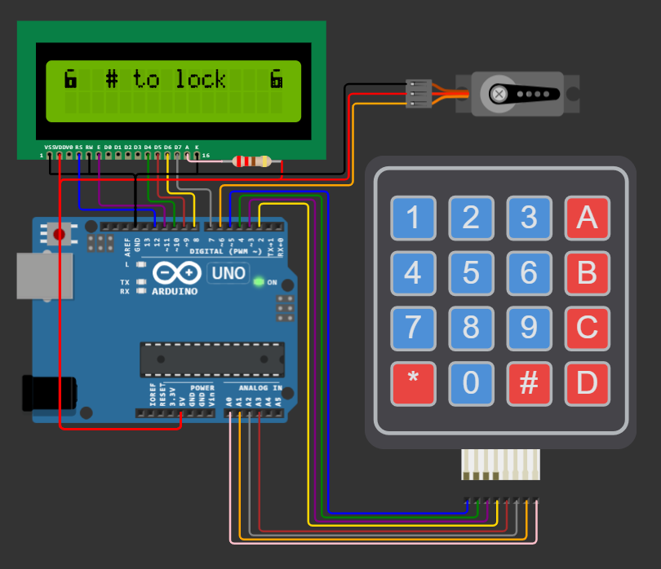

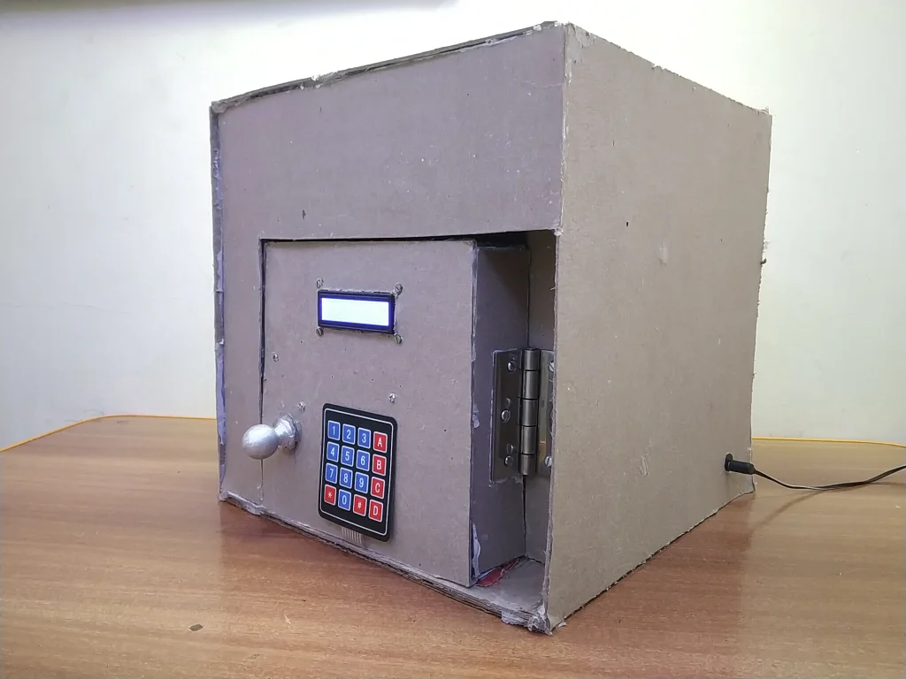

**References:**

Arduino Official Website: <https://www.arduino.cc/>

<https://github.com/Asitsp/IOT>

<https://trello.com/b/GrhYOAql/aisc2010final>